Practical no: 1
Aim:
Background information:
- Ribbon
The ribbon is the top menu bar in Power BI Desktop that contains tabs like
- Home
- Insert
- Modeling
- View
- Optimize
- Help
It provides quick access to all tools and commands.

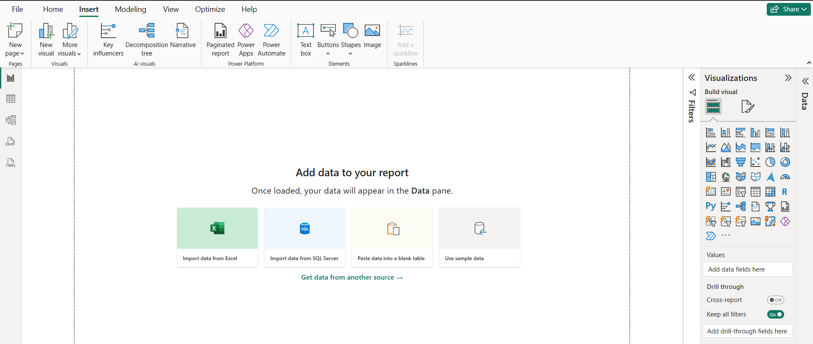

- Home Tab
The Home Tab is the main tab used for importing, transforming, and managing data.
Features:
- Get Data – Connect to Excel, CSV, SQL Server, Web, PDF, etc.
- Excel Workbook – Import data directly from Excel.
- Transform Data – Open Power Query Editor to clean and modify data.
- Refresh – Update data from the source.
- Recent Sources – Access recently used data files.
- Enter Data – Create a table manually.
- Manage Relationships – Connect tables using common fields.
- New Visual – Add charts and graphs.
- Publish – Upload reports to Power BI Service.
- Quick Measures – Create calculations automatically.

- Insert Tab
The Insert Tab is used to add visual and interactive elements to reports.
Features:
- Text Box – Add titles, notes, and descriptions.
- Image – Insert logos, photos, and graphics.
- Shapes – Add rectangles, circles, arrows, lines, etc.
- Buttons – Create navigation buttons.
- Icons – Insert icons for better design.
- Navigator – Create page navigation.
- Smart Narrative – Automatically generate report summaries.
- Blank Button – Create custom interactive buttons.

4) Modeling Tab
The Modeling Tab is used for creating calculations and managing relationships.
Features:
- New Measure – Create DAX calculations.
- Quick Measure – Create calculations automatically.
- New Column – Add calculated columns.
- New Table – Create custom tables.
- Manage Relationships – Create/edit relationships.
- Data Type – Change data type (Text, Number, Date).
- Format – Set currency, percentage, decimal places.
- Sort by Column – Sort one column using another.
- Mark as Date Table – Set a table for time analysis.
- Manage Roles – Apply Row-Level Security (RLS).
5) View Tab
The View Tab controls report layout and appearance.
Features:
- Themes – Apply predefined color themes.
- Customize Theme – Create your own theme.
- Gridlines – Show or hide gridlines.
- Snap to Grid – Align visuals automatically.
- Selection Pane – Show/hide report objects.
- Bookmarks Pane – Save different report views.
- Performance Analyzer – Check report performance.
- Page View – Fit report to page or width.
- Mobile Layout – Design reports for mobile devices.
6) Optimize Tab
The Optimize Tab Improve report performance and speed.
Feautres:
- Pause Visuals – Stops visuals from refreshing.
- Performance Analyzer – Checks visual loading time.
- Query Reduction – Reduces unnecessary queries.
- DAX Query Analysis – Analyzes DAX performance.
- Interaction Optimization – Improves visual interactions.

7) Help Tab
The Help Tab Provides learning resources and support.
Features:
- Documentation – Official Power BI guides.
- Community Forum – Ask questions and get help.
- Training & Tutorials – Learn Power BI.
- What's New – View latest updates.
- About Power BI – Check version details.
- Feedback – Send suggestions to Microsoft.
Steps:
Step1: Download first excel file and Power BI Desktop in PC or Laptop
Step2: Open Power BI Desktop then click on blank report.
Step3: Then click on Home then go to “Get data” then inside get data click on “Excel Workbook”.
Step4: After that select any file from the folder or upload any excel document and then click on “Open”.
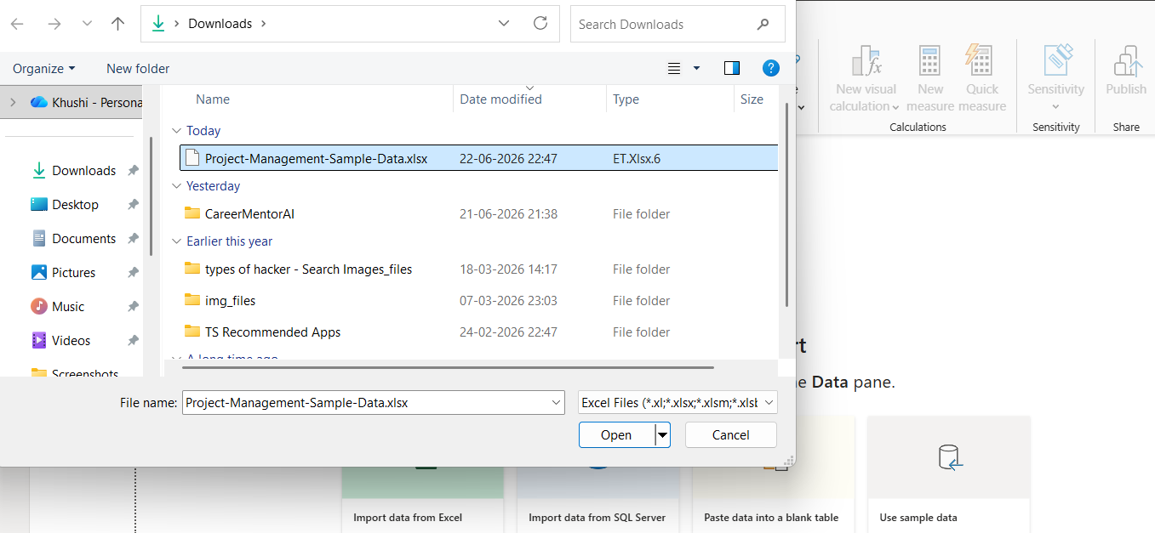
Step5: Then click on “Transfer data” then you will see like this something
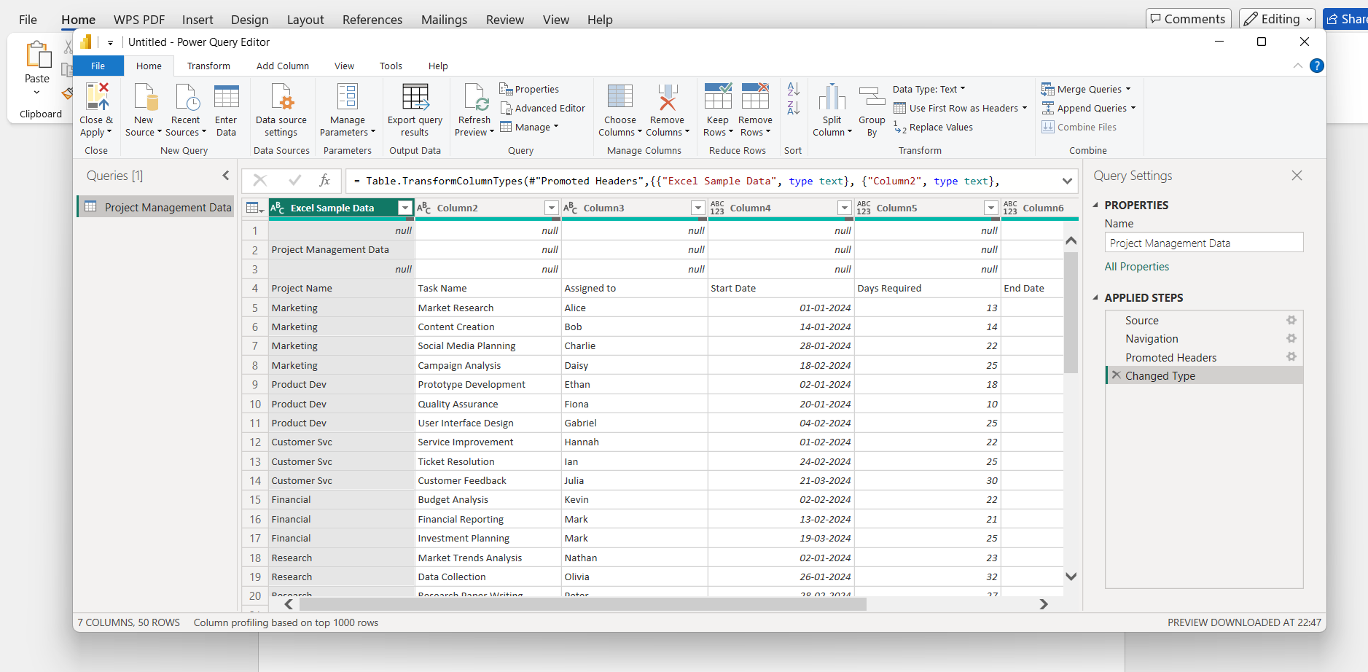
Step6: Now go to file and click on “New resources” then inside new resource click on “OData feed”
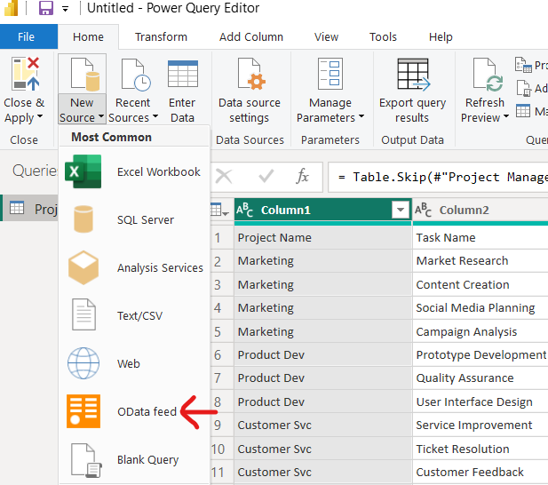
Step7: then you will see the URL put this URL in it “http://server.odata.org/V3/Northwind/Northwind.svc/ then click on next
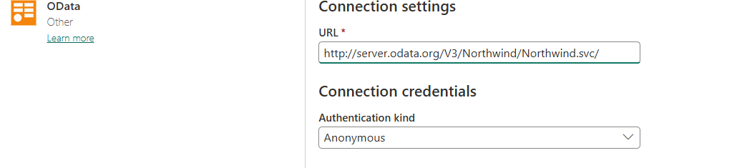
Step8: now select any option from the list again click on transfer data at the end you will see like this
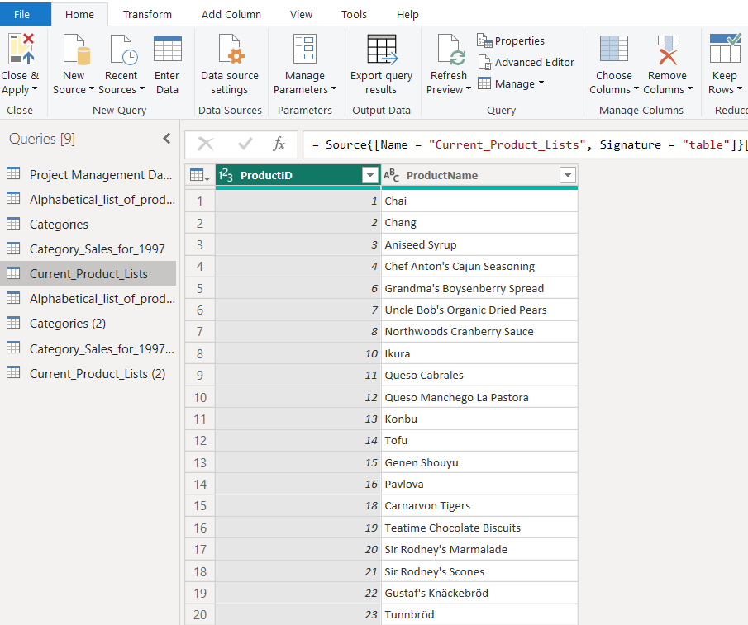

Practical no: 2
Aim: Pie chart & Stacked Column chart
Background information:
Steps:
Step1: Download first excel file and Power BI Desktop in PC or Laptop
Step2: Open Power BI Desktop then click on blank report.
Step3: Go to Visualization inside it go to Canvas Background
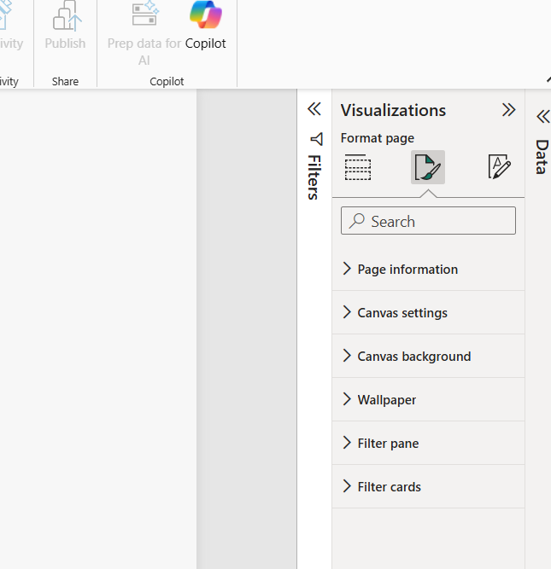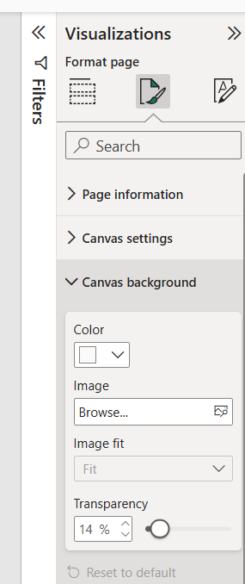

Ste4: Then click on browser take any plane background paper
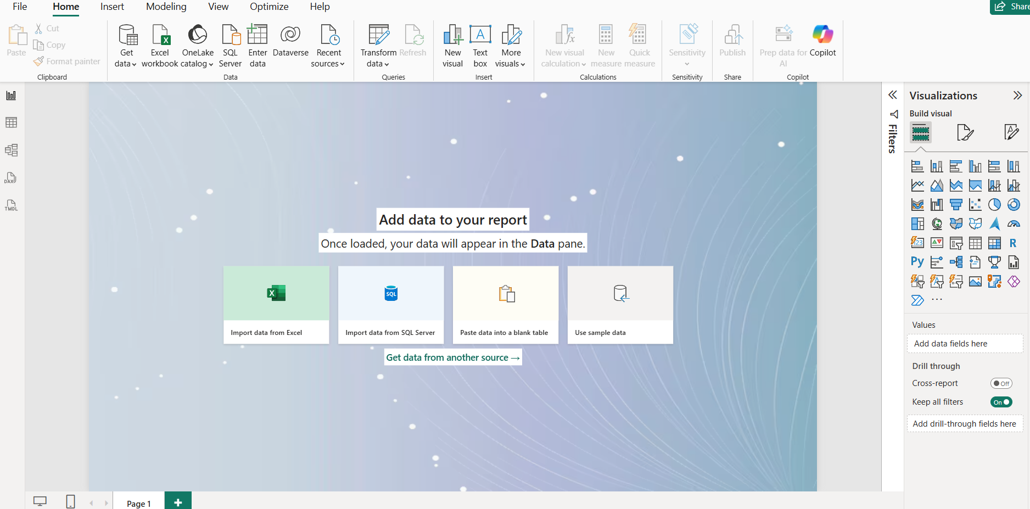
Step5: Then click on import data from excel
Step6: Import a sale data and then load it like this.
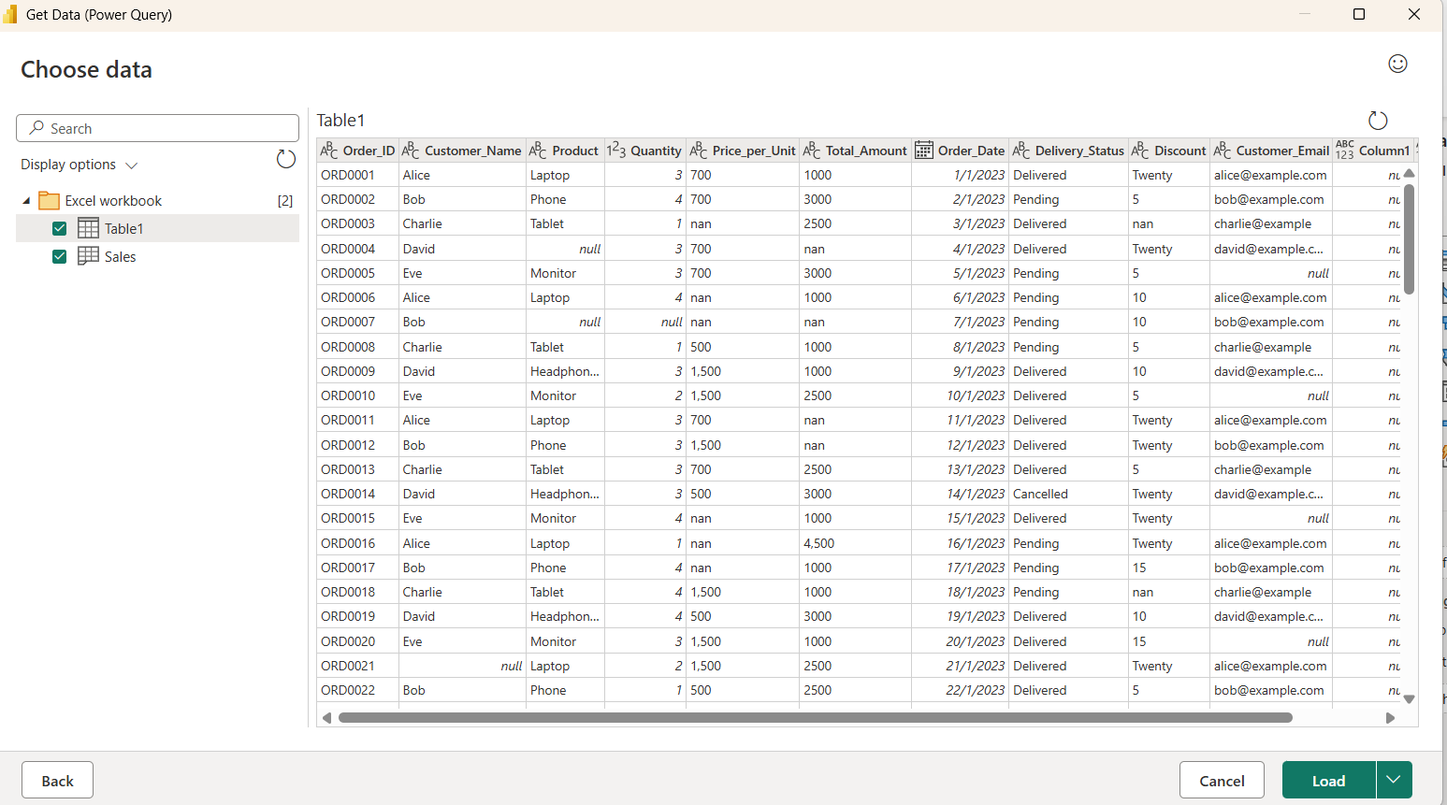
- See it loaded data.
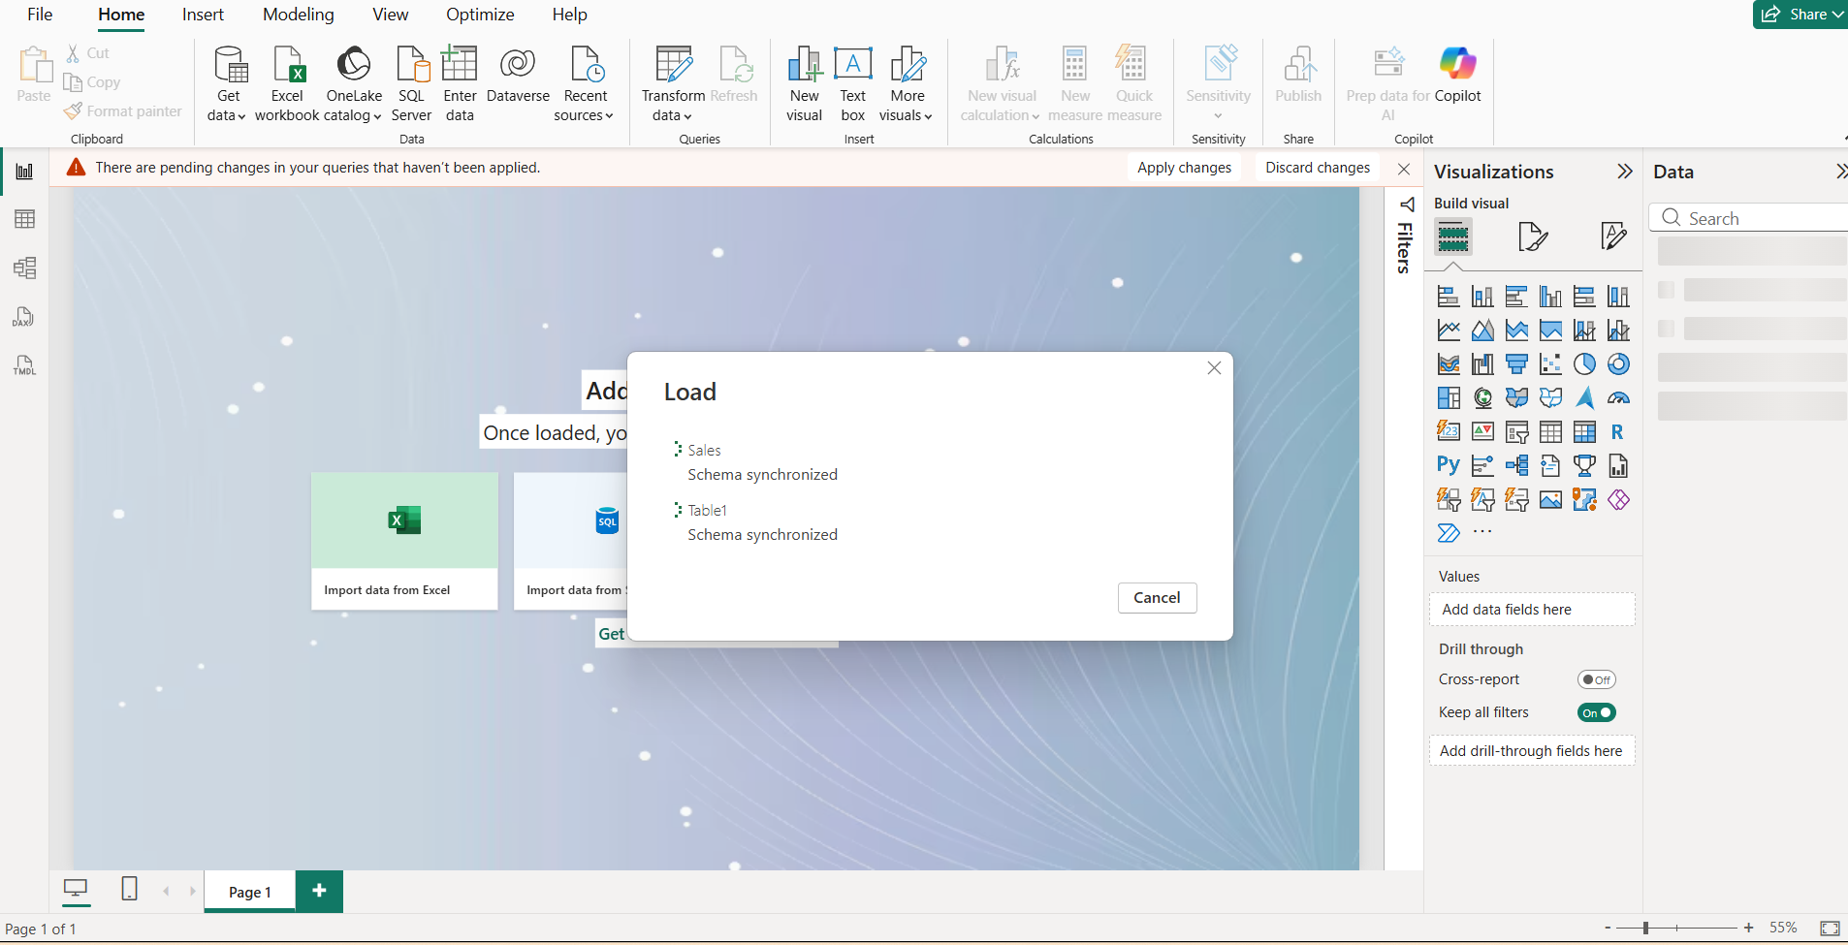
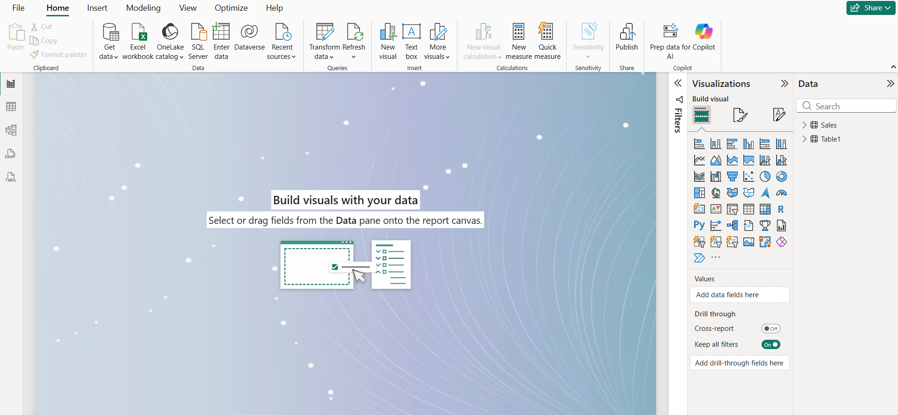

Step7: in the left hand side you will see the table and sale information
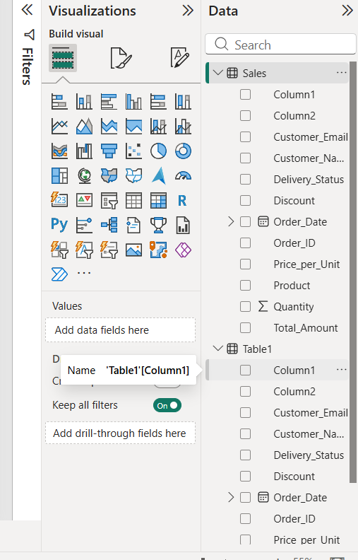

Step8: Now Go to Visualizations and Select Pie chart
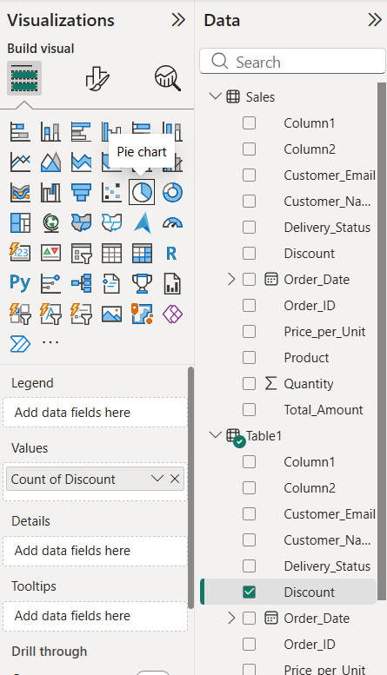
- After selecting Pie chart the screen will look like this
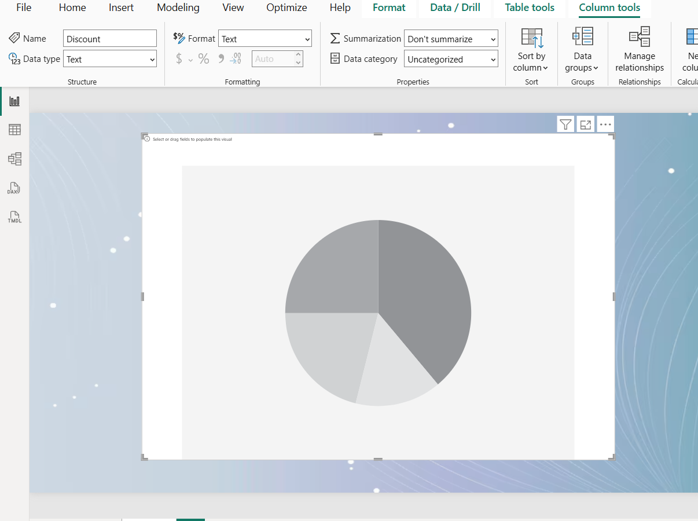
Step9: Then Select any data information from sales records and tables records
For eg: I m selecting
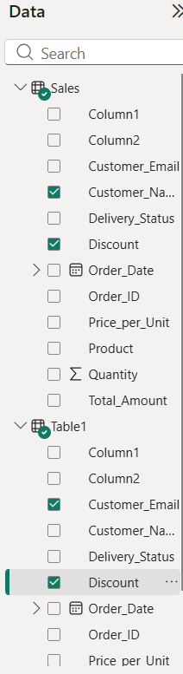
Step10: Then drag and drop all the selected data information in a values
For eg: drag and drop customer name in a values likewise drag any selected data from the list of sales and tables
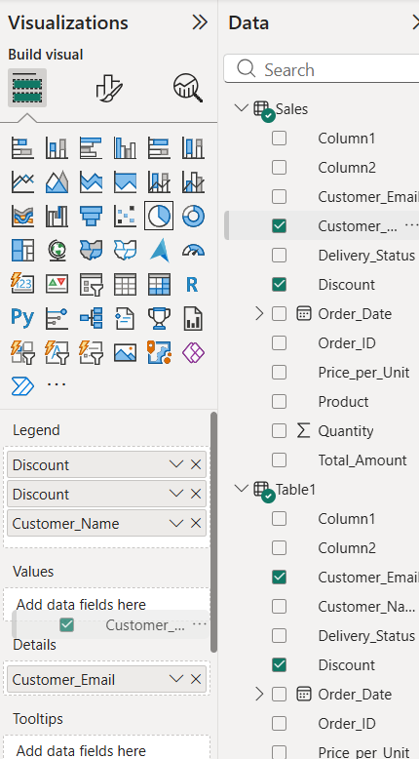
Step11: After drag and drop all the data information in a values the Pie chart will look like this
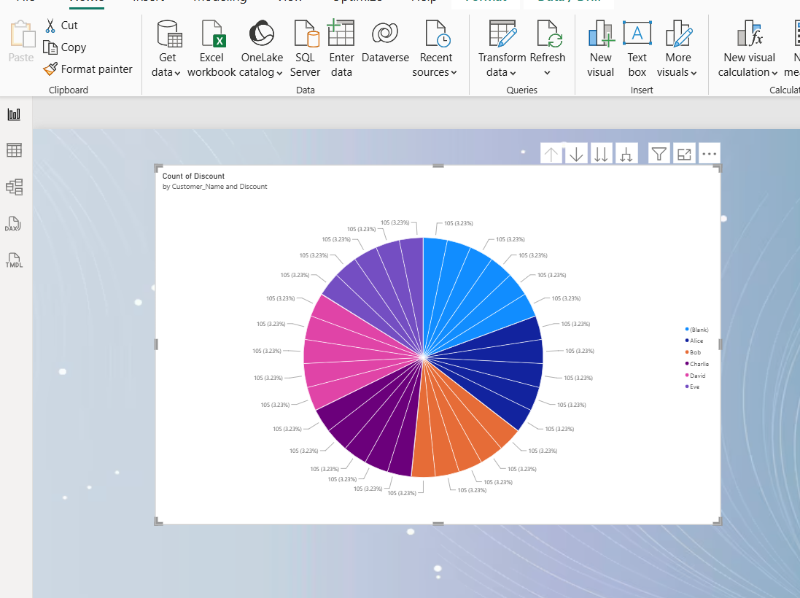
Step12: Then go to Visualization then go to General increase the Background transparency
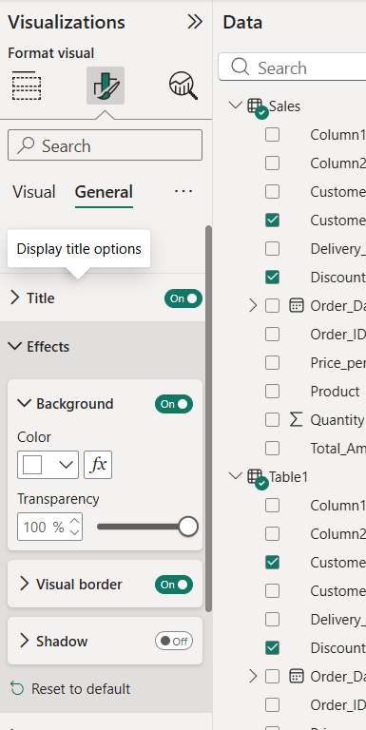
Step13: After this you will see the pie chart with proper background


